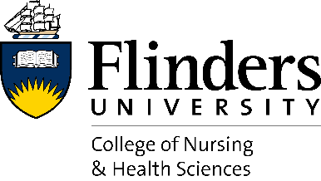
Last Updated: 06/04/2022
ONBOARDING

NEW STAFF BIO

So that we can introduce new staff to the College, please complete the following details for inclusion in the College of Nursing & Health Sciences internal newsletter, NHS News. NHS News is distributed on the first and third Wednesday of the month.

Name:

Position title & team/discipline:

What will you be doing in your role at Flinders University?

What are your credentials/past experience?

Where have you worked previously? Where have you come from?

What do you enjoy doing most when you’re not working?

Please return your completed form, along with a photo/headshot as soon as possible to cnhs.operations@flinders.edu.au.

Thank you!

