

COLLEGE OF NURSING AND HEALTH SCIENCES
RESEARCH PLAN 2023 – 2024

SECTION 1: ABOUT YOU
NAME:
POSITION TYPE: | ☐ Teaching and Research  ☐ Research-only
ACADEMIC LEVEL:
EMPLOYMENT FRACTION (FTE):
CAREER STAGE: | ☐ PhD candidate  ☐ ECR (0 to 8 years post PhD conferral)  ☐ MCR (9 to 15 years post PhD conferral)  ☐ Senior researcher (> 15 years post PhD conferral)  ☐ Other (please specify below):  Add any further detail / justification here:
RESEARCH AREA of FOCUS (select all that apply): | ☐ Healthy start to life  ☐ Ageing and aged care  ☐ Fundamental care  ☐ Cardiac and stroke care  ☐ Cancer care  ☐ Disability and Community Inclusion  ☐ Palliative care and end of life  ☐ Health emergencies and health security  ☐ Health and social care economics  ☐ Knowledge translation  ☐ Technology and digital health  ☐ Other (please specify below):
FLINDERS RESEARCH CENTRE MEMBERSHIP / AFFILIATION: | ☐ Caring Futures Institute (CFI)  ☐ Research Centre for Palliative Care, Death, and Dying (RePaDD)  ☐ Torrens Resilience Initiative (TRI)  ☐ Digital Health Research Centre  ☐ Sport, Health, Activity, Performance and Exercise (SHAPE)  ☐ Other (please specify below):
SECTION 2: REFLECTION ON RESEARCH GOALS AND PERFORMANCE OVER THE PAST 12 MONTHS
Reflect on your achievements regarding HDR supervision, publications, and external income over the past 12 months.
*Please indicate where “0” applies.
** Publications in top quartile 25% Scimago-ranked journals are highly encouraged.
*** It is recognised that external HDR Supervision may foster collaborations and build research capacity. However, staff should be conscious that there is no workload allocated for supervising external HDR students.
HDR supervision | N | Publications | N | Research Income | $
Masters |  | SJR (ranking quartile) |  | Please refer to income over the last 3 years captured in the “Supplementary Data for Academic Performance Review.”
Flinders Principal: |  | Total
Flinders Associate: |  | Q1
External: |  | Q2
PhD |  | Authorship order
Flinders Principal: |  | 1st authors
Flinders Associate: |  | Senior author
External: |  | Citation
 |  | Current ResearchNow Total citations

Remarks:

How do your HDR student supervision, publications, and external income compare to:
- Research Performance Expectations (refer to Schedule A)?
- National Benchmarks (refer to CFI National Benchmarking Tool)?
List your research goals over the previous 12 months here:
What were you able to achieve? What were not able to achieve and why?

SECTION 3: FORWARD PLANNING
Outline your 2024 goals with regards to HDR supervision, publications, and external income
*Please indicate where “0” applies.
** Publications in top quartile 25% Scimago-ranked journals are highly encouraged.
*** It is recognised that external HDR Supervision may foster collaborations and build research capacity. However, staff should be conscious that there is no workload allocated for supervising external HDR students.
HDR supervision | N | Publications | N | Research Income | $
Masters |  | SJR (ranking quartile) |  | Target for 2024:  $__________
Flinders Principal: |  | Total
Flinders Associate: |  | Q1
External: |  | Q2
PhD |  | Authorship order
Flinders Principal: |  | 1st authors
Flinders Associate: |  | Senior author
External: |  | Citations
 |  | Current ResearchNow  Total citations | Not Applicable

Outline up to 3 research goals for the next 12 months here
Please refer to the Research Careers Tool (Schedule B) to guide planning and discussions with your Supervisor
Name GOAL 1 here:

What strategies will you need to implement to help you achieve this goal?

What professional development and partnership opportunities might you engage in / need to support you to achieve this goal?

Describe the key performance indicators and timeframes for achievement of this research goal. How will this goal align with your 2024 goals in relation to HDR supervision, publications and research income?
Name GOAL 2 here:

What strategies will you need to implement to help you achieve this goal?

What professional development and partnership opportunities might you engage in / need to support you to achieve this goal?

Describe the key performance indicators and timeframes for achievement of this research goal. How will this goal align with your 2024 goals in relation to HDR supervision, publications and research income?
Name GOAL 3 here:

What strategies will you need to implement to help you achieve this goal?

What professional development and partnership opportunities might you engage in / need to support you to achieve this goal?

Describe the key performance indicators and timeframes for achievement of this research goal. How will this goal align with your 2024 goals in relation to HDR supervision, publications and research income?

SECTION 4: Contribution to the NEXUS Vision
Describe how you will contribute towards the excellence of NEXUS between teaching, research and clinical practice/policy aligned with this research plan in the next 12 months (be as specific as possible)

How will you know that you have achieved this goal (s) in relation to NEXUS?

SIGNATURE PAGE

STAFF MEMBER
- I confirm that the information supplied is correct.
- I understand that I may be asked to provide regular updates and progress reports to my academic supervisor and Dean (Research).
- I acknowledge that any workload allocation may be adjusted where consistent with the College Workload.
- I understand that I am required to obtain my supervisor’s statement and signature before sending this document to cnhs.deanresearch@flinders.edu.au
Signature of Staff Member |  | Print Name |  | Date
SUPERVISOR
Supervisor Supporting statement:
- Research Plans must be supported by the supervisor who must be satisfied that the research plan is of value to the staff members’ academic pursuits and the College overall. Please include a brief statement in support of this requirement:

Signature of Supervisor |  | Print Name |  | Date
CFI DIRECTOR AND DEAN OF RESEARCH
Dean (Research) Recommendation to Dean P&R:
Research Plans must be endorsed by the Dean (Research) who must be satisfied that the research plan is of strategic value to the staff members’ academic pursuits and the College’s strategic priorities.
Signature Dean (Research) |  | Print Name |  | Date
DEAN P&R (APPROVAL)
Dean (P&R) Approval:
I agree this application is of strategic value to the College’s strategic priorities and staff members’ academic pursuits:
Signature Dean (P&R) |  | Print Name |  | Date

Schedule A: Research Performance Guide

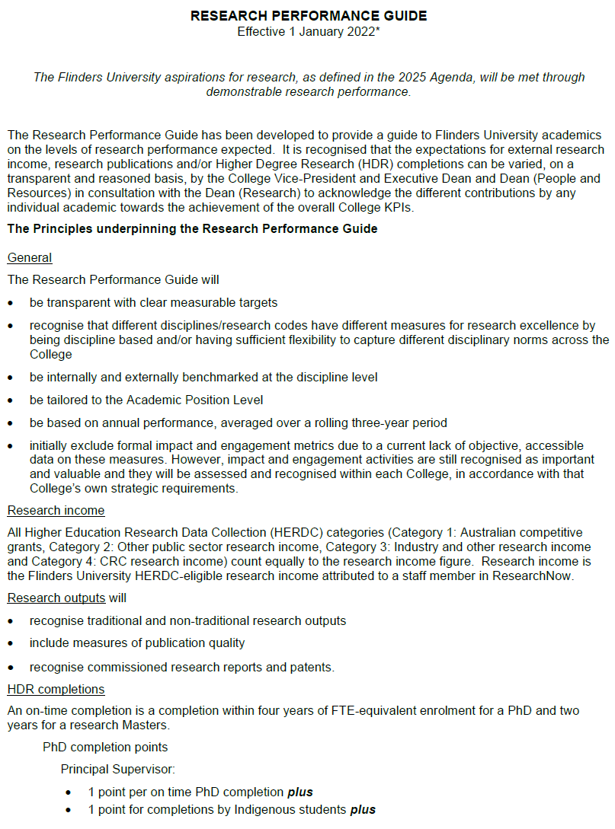

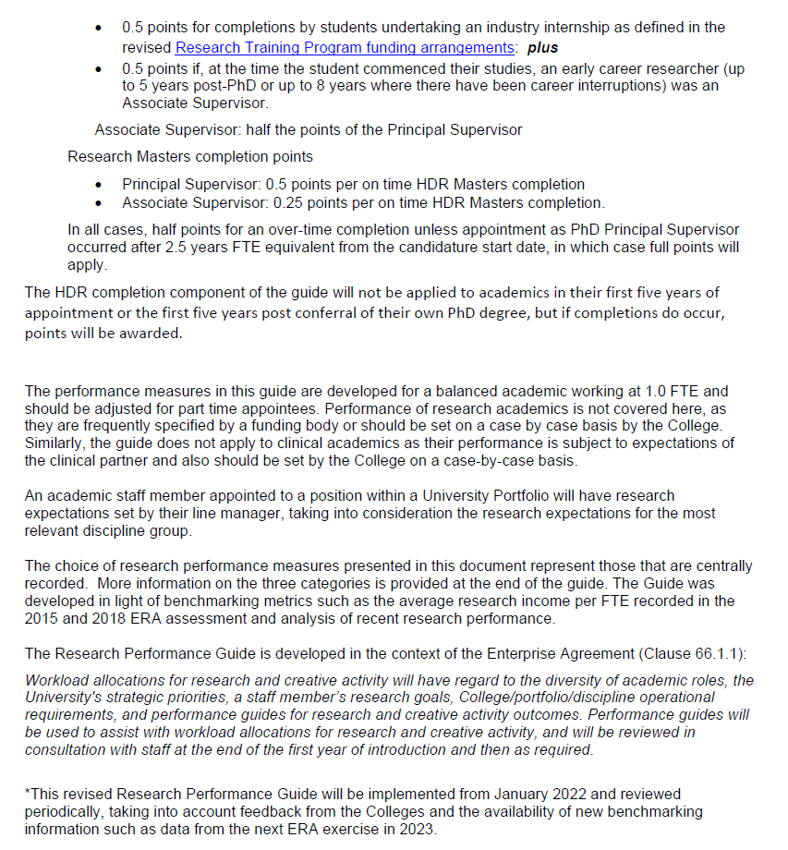

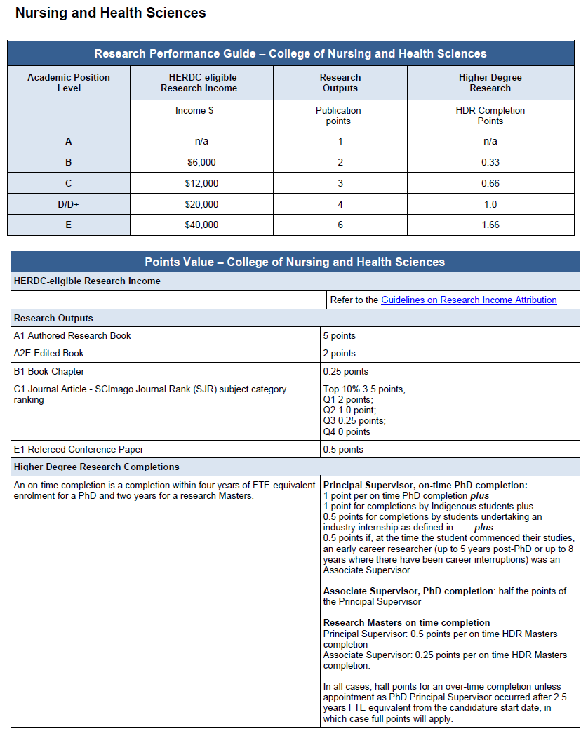

Schedule B: Research Careers tool

