Guide for raising Purchase Orders in Tech One Financials
Table of Contents
- How to Create a Purchase Order (non Capital Works)
- Printing the Purchase Order without the value showing
- Raising a Capital Works Purchase Order
- Reprint a Purchase Order
- How to Receipt a Purchase Order
- How to Cancel a Receipt
- Cancelling/Closing a Purchase Order
- Amending a Purchase Order

Important information to consider before raising a Purchase Order:
Please ensure the below criteria is read and adhered to when purchasing goods:
- Any purchases above $20,000 must have a Purchase Order. Below $20,000, should have a Purchase Order.
- Create new Purchase Orders for new contracts.
- Do not extend Purchase Orders
Ensure Quotes are obtained as per the below rules:
- 2 quotes required for above $5,000;
- 3 quotes for $15,000 - $100,000;
- Above $100,000 is Acquisition Plan
- or exemption from quote needs to be completed and retained for auditing purposes
To find out further information in relation to Purchase Order exemptions or to refer to the Purchasing Policy, please click here:

How to Create a PO (For Capital Works CW go to point 3)
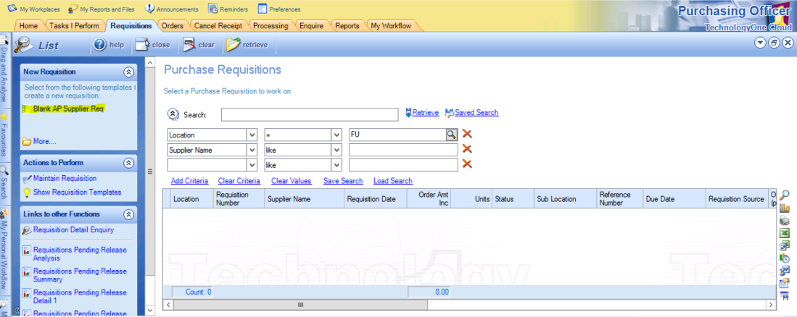
Requisitions Tab -> Click Blank AP Supplier Req under New Requisition (left-hand column)

The below information needs to be entered into the screen that populates
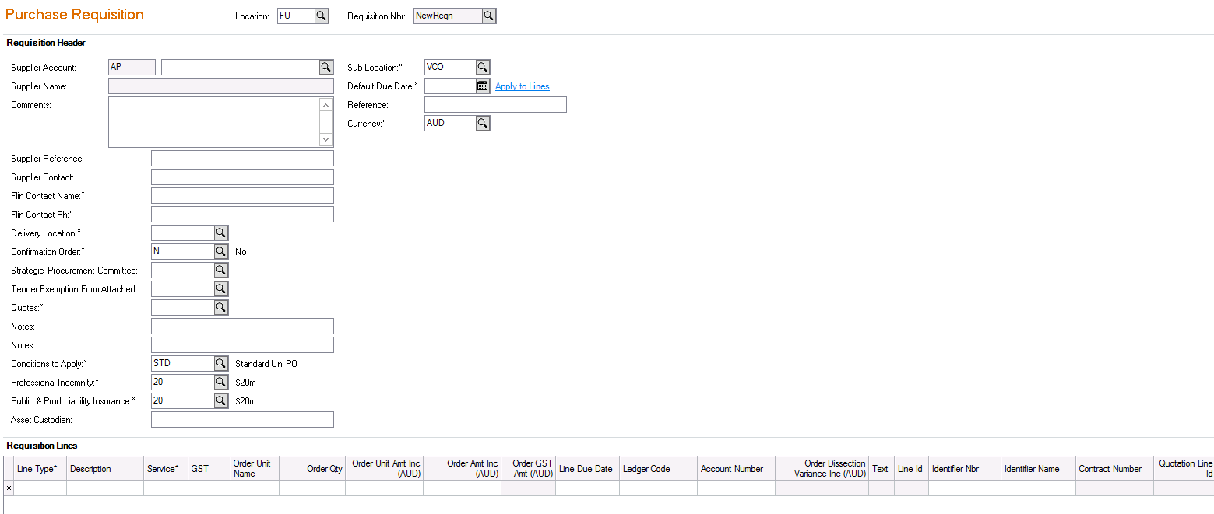
Supplier Account: Enter 6-digit AP vendor number if known, or click the search icon and search for the vendor
If the Vendor is not set up, send an email to accounts@flinders.edu.au including either an email from the new vendor, quote or letter head showing the business– ABN, address, phone number, email and bank account details.
Comments – This detail WILL appear on the PO, ensure any comment here is meaningful, e.g. description of goods/services, delivery only on Monday mornings, quote number, etc. The detail entered here is searchable in Tech One.
Supplier Reference: Quote number, etc. – This WILL NOT appear on the PO
Supplier Contact - This WILL appear on the PO
Flinders Contact Name: Contract Owner / Delegate / PO creator - This WILL appear on the PO
Delivery Location: Open selection to choose the relevant 3-digit code
Confirmation Order: Y/N for the words “Confirmation Only” to print/not print on the PO
Strategic Procurement Committee: Y/N - Must be Y if total contract value is $100k or above and need to attach SPC approval
Tender Exemption Form Attached: Y/N – if total contract value is $100k or above and did not go for tender. SPC approvals can also be tender exemptions. Note, TechOne makes you select Y or you will not be able to submit for approval.
Quotes: Pick an option – please ensure this meets requirements outlined under Important Information (page 1)
Notes: e.g. Completed Agreement and ROEC attached – this WILL NOT appear on the PO
Conditions to Apply, Professional Indemnity, Public & Prod Liability Insurance: Defaults
Sub location: Ensure correct area is selected
Default Due Date: Defaults supplier’s payment terms. Enter date that goods/service is required. This WILL appear on the PO
Reference: e.g. Contract LD Number, SPC reference number – This WILL NOT appear on the PO
Attachments: Agreement, ROEC, SPC approval, tender exemption, quotes, coding confirmation
Requisition Lines:
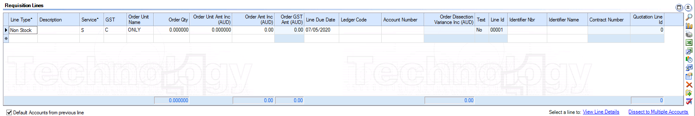
Line Type should always be “Non Stock” for GL accounts (see separate section for Capital Works, page 7

Description is mandatory as this information comes over to Basware - Enter a short meaningful description for each item
**if a more detailed description is required this can be extended by selecting Additional Line and Text Comments under Sections to Display in task pane.
Select Goods or Service – Goods will be a quantity at a rate; Service will be a total
Amounts needs to be GST inclusive

If a single line item needs to be coded to multiple GL accounts, click “Dissect to Multiple Accounts”
**note, when receipting, you cannot receive a higher amount than each line item, but in the dissection, you can split across the accounts any way that totals the amount received regardless of the amounts allocated to each GL code.
e.g. a PO for 100 hours of consultancy is to be used across the two projects 01.123.45678.xxxx and 01.987.65432.xxxx.
In Dissection to Multiple Accounts, you can split the total tine 50/50 to each account. As you receipt the PO, you can allocate the expenses in a 70/30 proportion
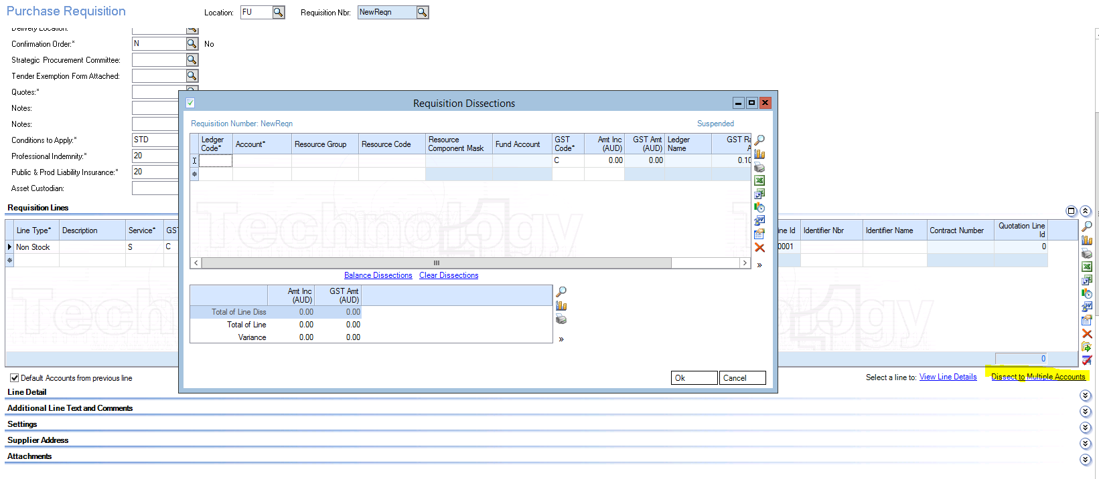

Line Due Date defaults to today’s date. Enter date the goods/service are required
You can add a new line item by clicking/tabbing off the first line, or by going into the Line Detail tab and clicking ”Add New Line”
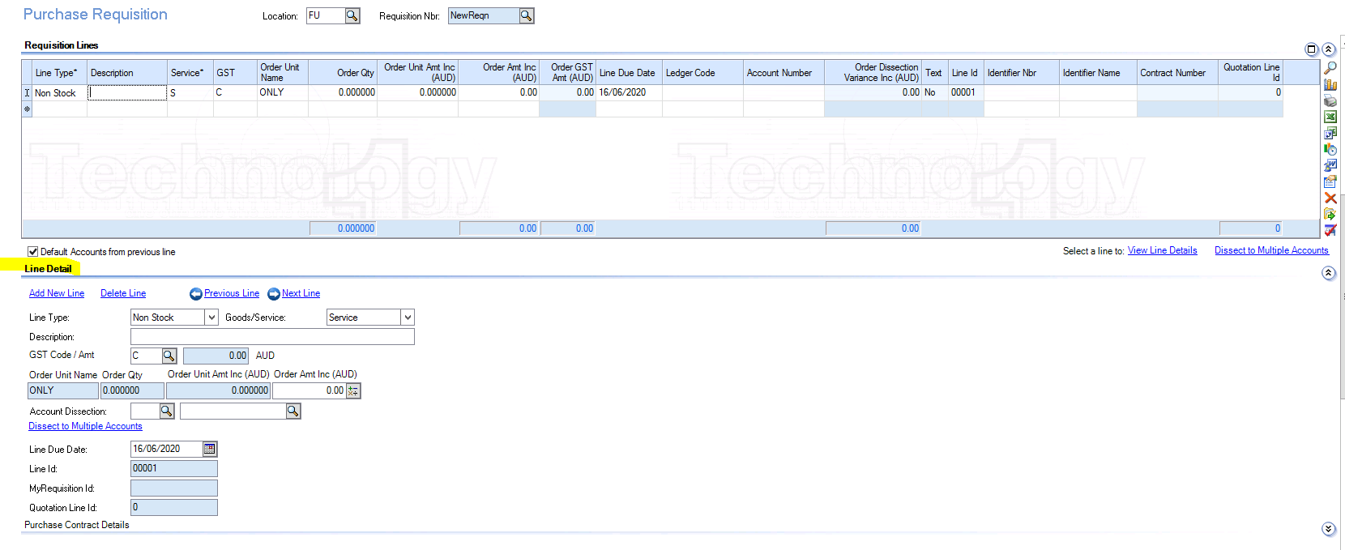

Click the Print Requisition on Save box under Actions to Perform if you require a copy before approval, then Save – you will need to change the email address or change the options for transmission. Take a note of Requisition Number in case of system errors.
Retrieve the Purchase Requisition by returning to the main screen (click “home”) in the Requisitions tab then click Retrieve. Go into the Purchase Requestion and Submit for Approval to appropriate Delegate based on Total Contract Value
Once your purchase order is approved or rejected by the approver, you will receive an email to advise you
If the purchase requisition is rejected, the order can be amended and resubmitted for approval to Delegate by clicking the requisition to open it, amend the order as necessary, and resubmit for approval.

Once it has been approved the status will change from Suspended to Accepted, in the main Purchase Requisitions tab, Release and Print Order (under Links to other Functions – left hand side) > find the related requisition and “Release and Print Selected Orders”. Email to Flinders mailbox and then send to Vendor as required.
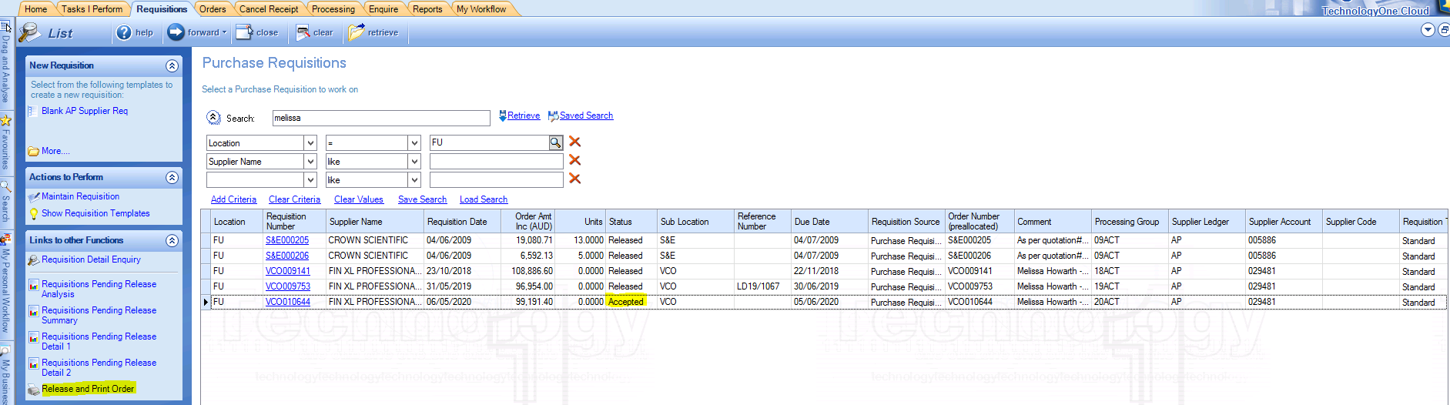

Note, you can Release and Print Purchase Requestions that were not created by you. In the Order Release and Print” page, change “Select Requisitions created using” from “Selected Auth Code” to “All Auth Codes” and delve the “Create User” criteria. Click retrieve and all available Purchase Requestions for release and print will appear

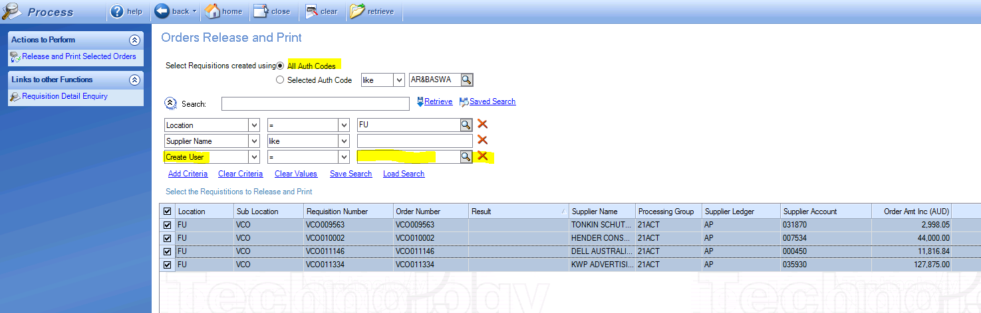

Printing the Purchase Order without the value showing

Note: when printing the PO, you can choose to not display the value.
To print a no value PO, when you click “Release and Print Selected Orders”, change the Document Definition from PORDER to PONOAMTDSP

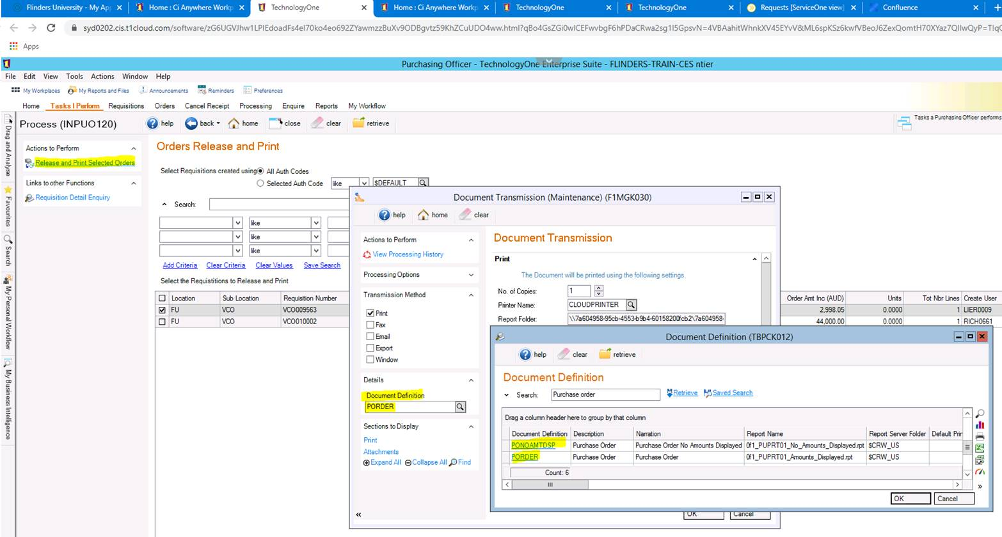

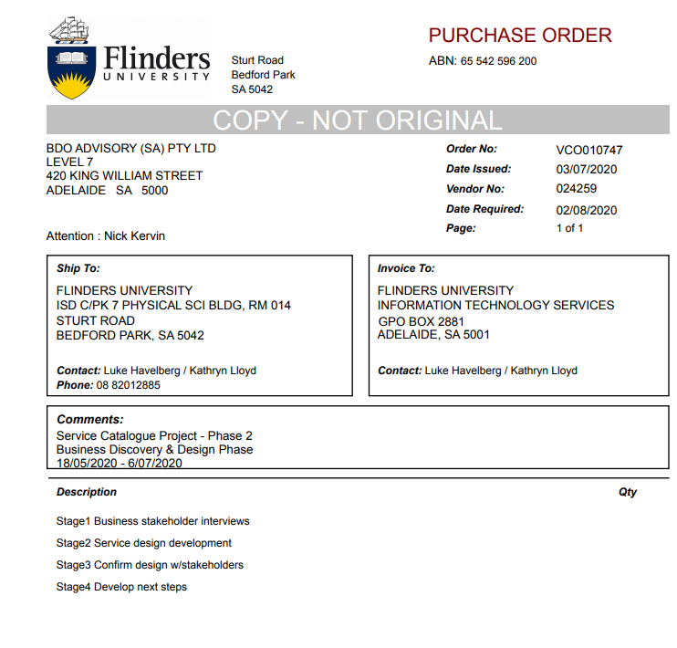

Raising a Capital Works Purchase Order

For Capital Works, the difference is on how to enter in Requisition Lines.
Line Type should always be ‘Catalogue’ for CW accounts
Next go to Identifier Name search button and select the appropriate Catalogue code
Search on Identifier Nbr and retrieve for the list of Catalogue products and select appropriate option.

Enter rest of details as required for Description, Services, Costs with Ledger Code = CW and appropriate CW account.

Reprint a Purchase Order

In the Processing tab, under Bulk Order Printing, select “Re-Print Orders”
Search for the PO, select it, and under Actions to Perform, click “Re-Print Selected Order”
Note: you can also choose to print the PO with or without amounts displayed. Change the Document Definition to PONOAMTDSP if you need to print without the value or amounts showing.
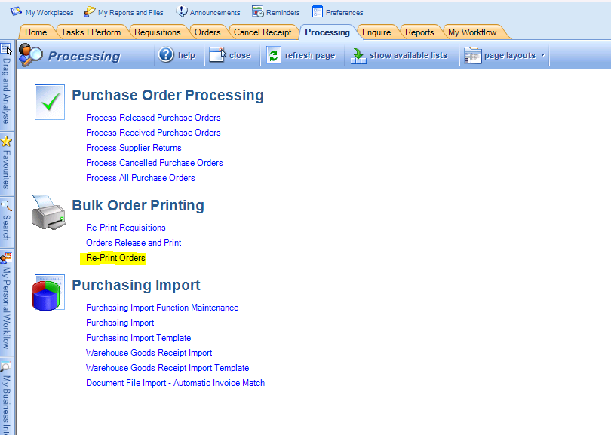

How to Receipt a Purchase Order

In the Orders tab, search for the PO and click on the Order Number
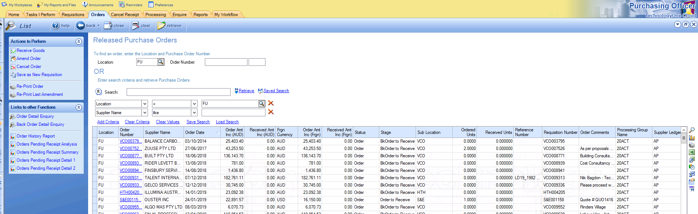

In Receipt Comments put the invoice number and any other relevant information
Enter the line item amounts in Delivered Amt Inc for Service and Delivered Qty for Goods. This amount needs to be GST inclusive
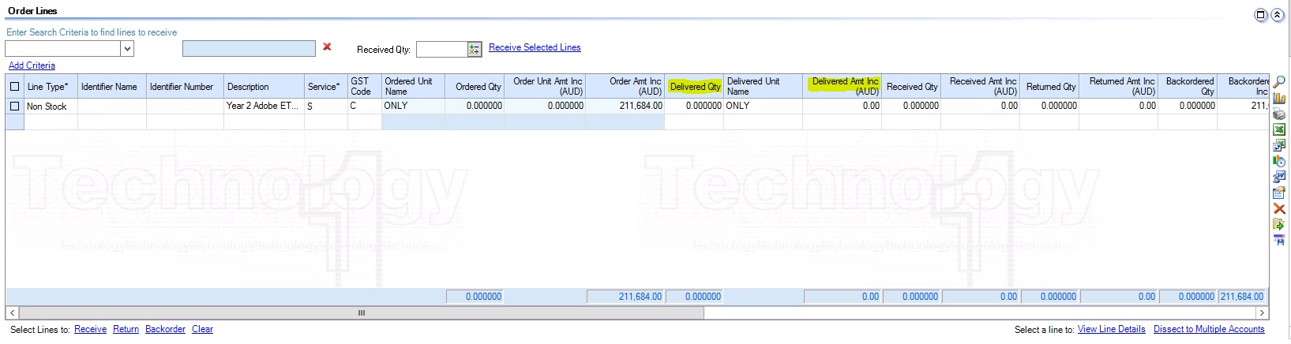

*Make sure the Backordered Amt Inc fills in, if the total PO amount is not being receipted. Need to ensure this for all lines – sometimes TechOne will not automatically backorder lines that were not receipted.
Attach the invoice approvals and any other relevant documents

When the receipt matches the invoice, click Approve in Actions to Perform
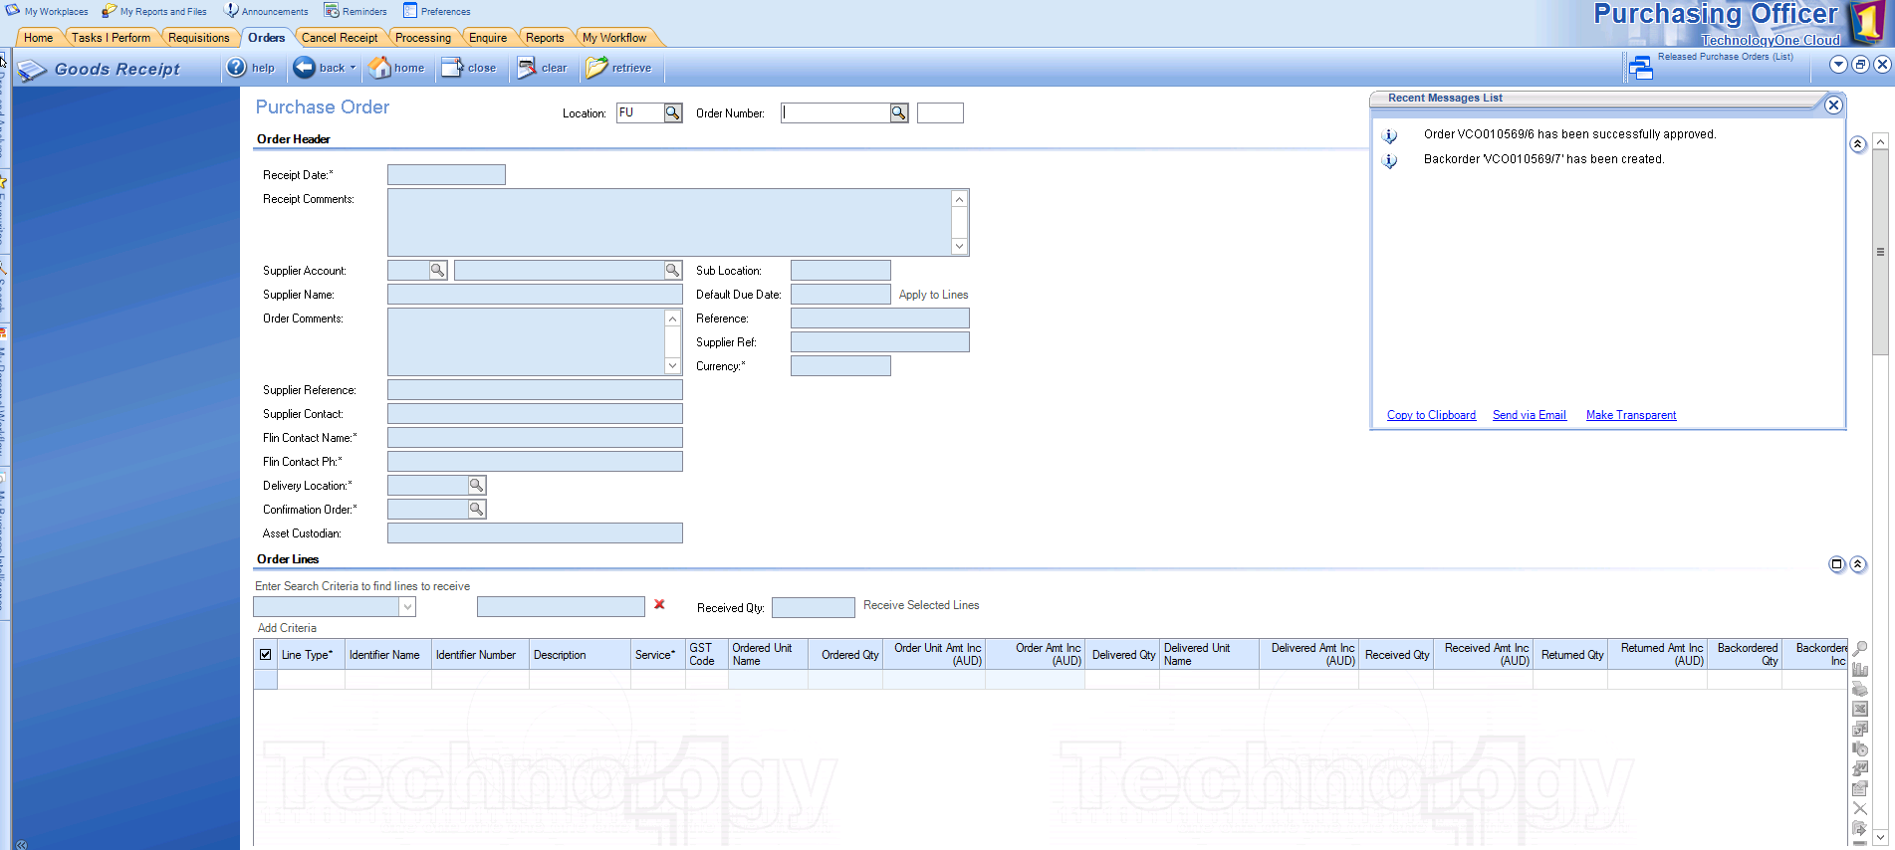
A notification will appear to confirm the receipt has been approved and if applicable, a backorder has been created

In Basware, return to Master User and advise them of the PO number and receipt number (e.g. VCO010700/4 for the 5th receipt against PO VCO010700)

How to Cancel a Receipt

In the Cancel Receipt tab, enter the Order Number, and receipt number if multiple and retrieve.
Note, receipt number for first receipt is 0, second receipt is 1, etc.
Note, you cannot cancel a receipt that an invoice has been matched to.
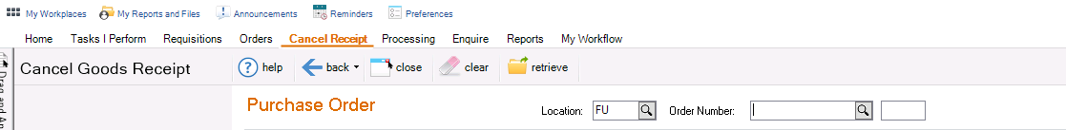

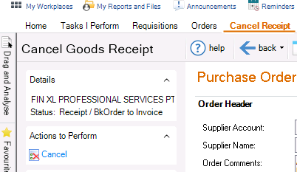

Under Actions to Perform
select “Cancel”

Then Yes to continue
Next message - select Yes to delete backorders
  - this will reset amount back to remaining PO with same receipt number now open (i.e. the one VCO010527 - 3). If you select No it will stay as two open PO’s items (if there is already another backorder) i.e. VCO010527 - 3 (the cancelled receipt amount) & VCO010527 - 4 (remaining amount) - i.e. 2 lines of the PO with separate “To Receive” amounts instead of rolling the backordered amount together
Please note – you cannot always select Yes. Selecting Yes will merge the remaining backorders into one.
If there are no other backorders in the PO, and you are cancelling a receipt that is not the latest one - you will need to select No.
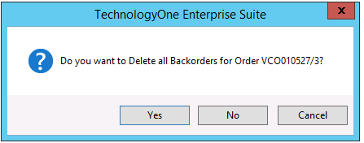

Cancelling/Closing a Purchase Order
This can be done if the PO has no open receipts (i.e. receipts have invoices matched to them). You can cancel/close a PO that has not been receipted or is partially receipted and has backorders.
If the PO has a partial receipt and no invoice matched, first cancel the receipt, and then proceed to close the PO.
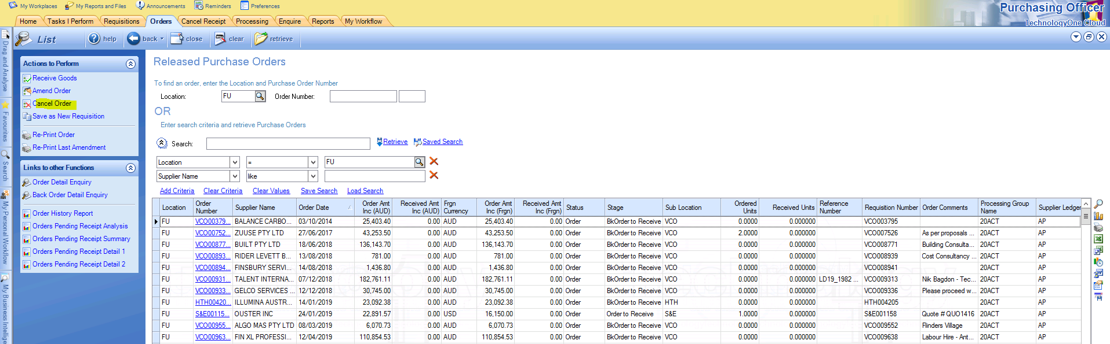
In the Orders tab, search for the PO and click ‘Cancel Order”

Select the PO, update the Cancel Reason,
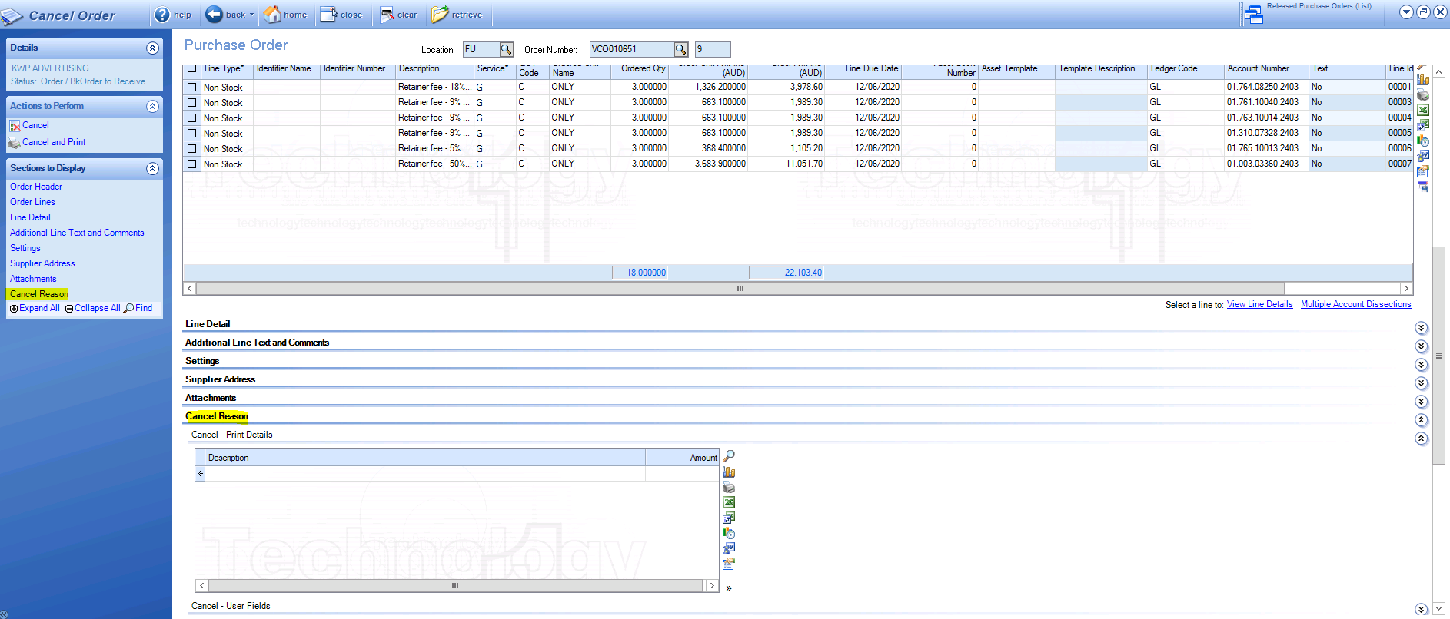

Click on “Cancel” under Actions to Perform

Amending a Purchase Order

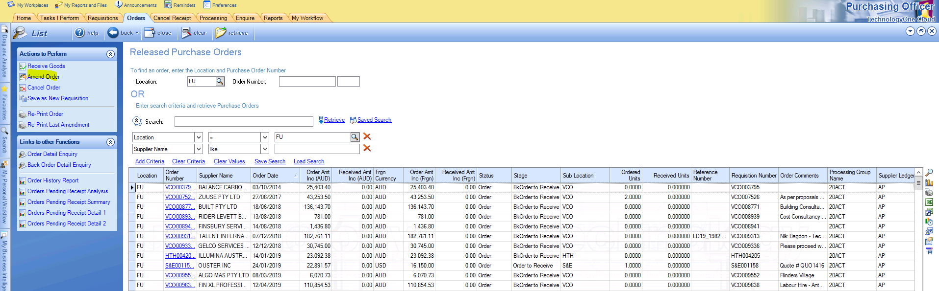
In the Orders tab, search for the PO and click “Amend Order”

Update the required information as you would when creating the PO, and re-submit for Approval with the delegate

Updated on 25/06/2021

Printed versions of this document are not controlled. Please refer to the Flinders Policy Library for the latest version.

