Flinders University Self‐Assessment Workstation Checklist Ver 3.0 (6/12/2024)
If you can tick all of the green or white boxes below then the work station meets the required Standards.
Name: Click or tap here to enter text. Supervisor: Click or tap here to enter text.  College / Portfolio / Business Area: Click or tap here to enter text.  Location: Click or tap here to enter text. | Extension: Click or tap here to enter text.  Date checked: Click or tap to enter a date.
Normal Work Activities: Click or tap here to enter text.
Desktop PC ☐ Mac / iMac ☐ Laptop / Macbook ☐
Keyboard Work ☐ Manual Handling ☐ Varying Multiple Tasks ☐ Frequent movement ☐
Desk |  | Y | N | NA
Is the desk or bench space large enough to accommodate all work (width and depth)? |  | ☐ | ☐ | ☐
Can the desk height be adjusted to suit the worker? (i.e. height adjustable or adjustable feet) |  | ☐ | ☐ | ☐
When working at the desk (sitting / standing), is the desk at elbow height (i.e. not raised to desk)? |  | ☐ | ☐ | ☐
Is there sufficient leg room beneath the desk or bench (650mm wide x 450mm deep at least free)? |  | ☐ | ☐ | ☐
Is the desktop free of reflections / glare from its surface? |  | ☐ | ☐ | ☐
Are frequently used items within normal reach (i.e. without overstretching)? |  | ☐ | ☐ | ☐
If a keyboard tray is present, can it adjust freely? Position: ☐ Level ☐ Lowered ☐ Can’t Adjust (repair) |  | ☐ | ☐ | ☐
If a corner desk is used, does it have a corner support or desk lozenge correctly installed? |  | ☐ | ☐ | ☐
Height adjustable / Sit Stand Desk |  | Y | N | NA
Can the workstation be adjusted to suit the worker at a sitting posture? |  | ☐ | ☐ | ☐
Can the workstation be adjusted to suit the worker at a standing posture? |  | ☐ | ☐ | ☐
Is the worker aware of the correct height for sitting and standing (i.e. marked / desk programmed out the levels)? |  | ☐ | ☐ | ☐
If prolonged standing and cannot vary tasks, is a mat provided or alternative solution utilised? |  | ☐ | ☐ | ☐
Chair |  | Y | N | NA
Is the chair cushion / padding in good condition (i.e. not worn, dirty, lost its support)? |  | ☐ | ☐ | ☐
If chair has arm rests, are they adjusted correctly to avoid impact on swivel action or seating position? |  | ☐ | ☐ | ☐
Is the base of the chair stable (i.e. at least has a five-star base and has no ‘wobbles’)? |  | ☐ | ☐ | ☐
Does the seat width and depth comfortably support the hips and legs? |  | ☐ | ☐ | ☐
Does the chair offer adjustable lumbar support to support your lower back? |  | ☐ | ☐ | ☐
Is the chair adjustable and working? |  | ☐ | ☐ | ☐
Is the chair backrest angle adjustable and working? |  | ☐ | ☐ | ☐
Footrest |  | Y | N | NA
If a footrest is required, is one present, adjusted correctly and in working order? |  | ☐ | ☐ | ☐
Are feet flat on floor or a footrest used to maintain thighs parallel to floor? |  | ☐ | ☐ | ☐
Laptop / Tablet / Computer case |  | Y | N | NA
If the laptop / tablet is used for prolonged periods, is an external keyboard, mouse, monitor and / or docking station used? |  | ☐ | ☐ | ☐
If present, is the desktop computer case / docking station positioned to minimise impact on desk space? |  | ☐ | ☐ | ☐
Keyboard and Mouse |  | Y | N | NA
Is the keyboard used without propping up with the legs or thin keyboard used (i.e. 30mm or less high)? |  | ☐ | ☐ | ☐
Is the keyboard wrist support provided? ☐ Plastic ☐ Gel ☐ Other ☐ None |  | ☐ | ☐ | ☐
Is keyboard in good working condition (i.e. keys require normal pressure to use, clean)? |  | ☐ | ☐ | ☐
Is the mouse comfortable to use, moves freely and fits in your hand? |  | ☐ | ☐ | ☐
Is the mouse at the same level and as close as possible to the keyboard on the work surface? |  | ☐ | ☐ | ☐
Are the keyboard and mouse within 10 – 15cms from desk edge and directly and symmetrically in front of the seated position? |  | ☐ | ☐ | ☐
Are wrists in a neutral position when using the keyboard and mouse (i.e. wrist not bent)? |  | ☐ | ☐ | ☐
Display / VDU screens (Computer/ laptop/ tablet screens) |  | Y | N | NA
How many screens are present? Choose an item. If more or other: Click or tap here to enter text.
What configuration are the screens used? Choose an item.
Are the most used screen(s) positioned directly in front of the worker (minimise neck bending / twisting)? |  | ☐ | ☐ | ☐
Is the screen at a comfortable reading distance (approximately an arm’s length away)? |  | ☐ | ☐ | ☐
Is the image clear and stable (i.e. not flickering, rolling, dull, too bright, screen size adequate)? |  | ☐ | ☐ | ☐
Is the operator looking at the top edge of the screen without bending the neck? |  | ☐ | ☐ | ☐
Is screen height is adjustable? If not, is a monitor riser used? |  | ☐ | ☐ | ☐
Lighting (natural and artificial) |  | Y | N | NA
Is proper lighting available for the task (i.e. not too bright or too dull)? |  | ☐ | ☐ | ☐
Workstation surfaces are free from glare (i.e. lighting is not reflecting brightly into eyes)? |  | ☐ | ☐ | ☐
Are screens located so that users do not look directly toward or away from windows or strong light sources? |  | ☐ | ☐ | ☐
Noise |  | Y | N | NA
Does the noise level allow for concentration? |  | ☐ | ☐ | ☐
Is noisy equipment located away from the immediate workstation area (i.e. separate room)? |  | ☐ | ☐ | ☐
Telephone |  | Y | N | NA
Is the telephone positioned to avoid reaching across the body and within normal reaching range? |  | ☐ | ☐ | ☐
Is the correct posture used when answering the phone (i.e. not cradling phone in‐between shoulder and head; using headset; use speakerphone)? |  | ☐ | ☐ | ☐
Environment |  | Y | N | NA
Is the room / area at a comfortable temperature (i.e. air conditioning works properly)? |  | ☐ | ☐ | ☐
Is the work environment clean and tidy (i.e. no dust, leaks in roofs, strong odour issues)? |  | ☐ | ☐ | ☐
General |  | Y | N | NA
Is current posture preventing neck twist or strain? |  | ☐ | ☐ | ☐
If a document holder or adjustable surface is required, is it present, positioned and adjusted correctly? |  | ☐ | ☐ | ☐
Is varying of tasks, where possible, and / or breaks used to move away from the workstation occasionally? |  | ☐ | ☐ | ☐
Is there enough space to perform regular job tasks? |  | ☐ | ☐ | ☐
Are cables secured and do not present a trip or entanglement hazard? |  | ☐ | ☐ | ☐
Details and Other Notes (any issues noted should be discussed with your supervisor)
Click or tap here to enter text.
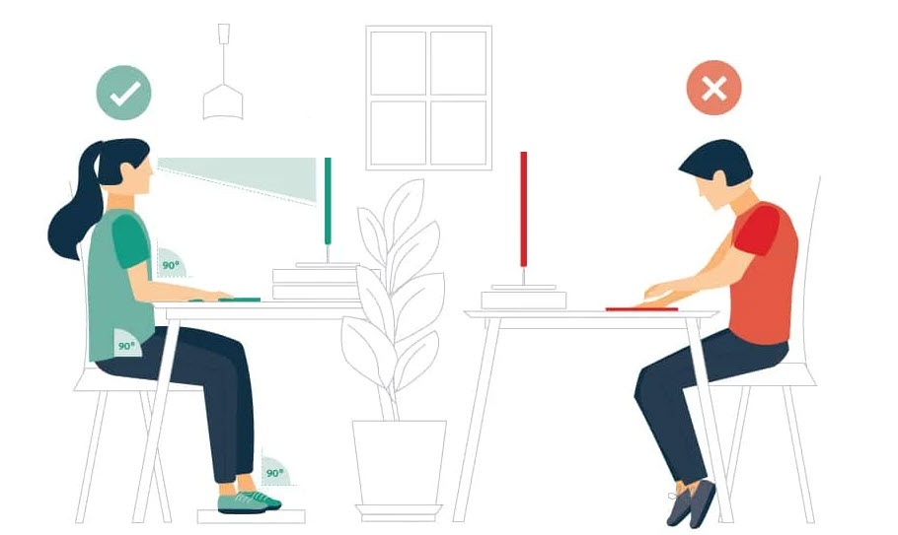
Source: https://hw.qld.gov.au/

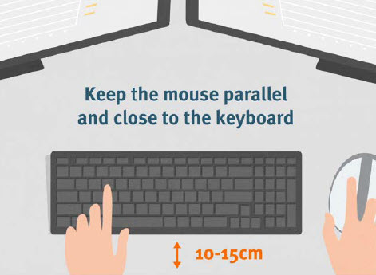  Source: https://www.worksafe.qld.gov.au/ | 