VEHICLE INSPECTION CHECKLIST
- This inspection checklist is designed for use on University provided motor vehicles (sedans / station wagons / utilities) only and is to be conducted on the vehicles that are to be taken for long distance, remote or 4WD prior to starting the trip
- Where an inspection identifies any substandard issues that impact on the safe use of the vehicle, it should be removed from service and the keys removed and secured to prevent unauthorized use until the issue is rectified.
VEHICLE DETAILS
Vehicle registration : |  |  |  | Odometer (km):
Date of inspection: | / / |  |  | Time of inspection: |  | am / pm
I verify that the following inspection has been completed and the vehicle has either been assessed as being in a safe condition and suitable for use or has been removed from service so that all issues identified below can be rectified.
Name of driver: |  |  |  | Signature:
GENERAL INSPECTION CRITERIA |  | FINDING | LIGHT INSPECTION CRITERIA |  |  |  | FINDING
Tyres – visual check that they are not damaged, worn or under inflation |  | Pass  Fail | Indicators |  |  |  | Pass  Fail
No obvious fluid leaks – check on ground under vehicle for any obvious sings of leak |  | Pass  Fail | Brake lights |  |  |  | Pass  Fail
Horn working |  | Pass  Fail | Tail lights |  |  |  | Pass  Fail
Handbrake and footbrake – firm to apply |  | Pass  Fail | Head lights |  |  |  | Pass  Fail
Wipers/ washers have fluid and working |  | Pass  Fail | Parking lights |  |  |  | Pass  Fail
Rear and side mirrors intact and adjusted to give clear view |  | Pass  Fail | Hazard lights |  |  |  | Pass  Fail
Seat belts all working and in good condition |  | Pass  Fail |  |  |  |  | Pass  Fail

DESCRIBE & MARK ON THE DIAGRAM ANY BODY DAMAGE TO THE VEHICLE:

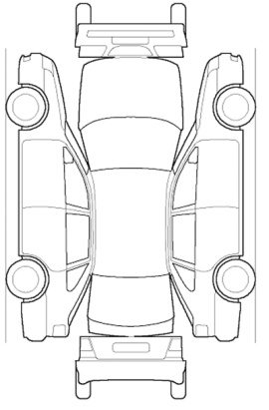
CORRECTIVE ACTIONS | RESPONSIBILITY

