PLANT DESCRIPTION: |  |  |  | Assessed by: | College/ Portfolio
 |  |  |  |  | NAME(S):
RISK ASSESSMENT NO: |  | Assessment Date: |  | Review Date: | when circumstances, procedures &/or information change | Area Supervisor:

Plant details (if relevant): |  |  |  |  | *Associated / cross-reference documents (if relevant):
Location: |  | Make/Model: |  |  | HazChem RA(s) |  | SWP:
Serial #: |  | Asset/EST #: |  |  | Plant RA(s)

Identified Hazards |  |  | Risk Assessment |  | Risk  Level  (see matrix ) | Required Controls  (consider control hierarchy) | Residual Risk |  | Risk  Level  (see matrix ) | Controls  implemented
Hazard Class | Hazard Description Prompts | Comment / Specific Details | Consequence | Likellihood |  |  | Consequence | Likellihood |  | Yes | No
Physical
Environment
Chemical
Biological
Radiation
Ergonomic
Training
Combination
Other

ADDITIONAL INFORMATION:

 | List any relevant Standards, Regulations, Codes of Practice, policies pertinent to the design and/or safe operation of this plant:
 |  |  | YES | NO
 | Is this plant required to be registered under the Work Health and Safety Regulations?
 | If YES, is inspection and maintenance information available?
 | Is the operator of this plant/equipment required to be licenced, certificated or deemed competent?
 | If YES, is relevant documentation available?
 | Is an operation manual available for this plant/equipment?
 | *Have you identified any hazardous chemicals used with this plant/equipment? – You must risk assess all associated hazardous chemicals.
 | If YES, please enter document cross-reference details on page 1.
 | *Have Safe Work Procedures been developed for this plant/equipment?
 | If YES, please enter document cross-reference details on page 1.
\
SUMMARY OF RISK:
Review the risk measured, and the controls, then please select the relevant risk summary statement:

A | The assessment reveals that the potential risk to health from the use of the plant is not currently significant
B | The assessment reveals that the potential risk to health from the use of the plant is significant, however controls are in place that reduce risk to acceptable levels
C | The assessment reveals that the potential risk to health from the use of the plant is significant. Interim controls are in place to reduce risk to acceptable levels.

Approved by Area Supervisor:
 | signature |  | date
REVIEW OF CONTROL MEASURES
Control measures are effective – yes *no (*If no, you must do another Risk Assessment)

Date Reviewed: |  | Signed:

HOW TO ASSESS THE RISK

Step C – Calculate the Risk Level
- Take the Step A rating and select the correct line in the matrix below.
- Take the Step B rating and select the correct column in the matrix below.
- Circle the risk level where the two ratings cross in the matrix below

Risk level =
Step A - Consider the consequences |  | Step B - Consider the likelihood
For each hazard, consider the consequences if something happens. Consider what could reasonably have happened, as well as what actually happened (if there was an accident/incident). Look at the descriptions below and choose the most suitable consequence below. |  | How likely is it that something will happen as a result of the hazard?  Choose the most suitable Likelihood below.
Consequence | Description | Likelihood | Description
Catastrophic | May cause death or permanent disability, and/or permanent ill health | Very likely | Expected to occur in most circumstances
Major | Severe injury or illness | Likely | Will probably occur in most circumstances
Minor | Minor (usually reversible) injury or illness resulting in days off work | Possible | Might occur occasionally
First Aid | First aid level medical treatment | Unlikely | Could happen at some time
Negligible | No treatment required | Highly unlikely | May happen only in exceptional circumstances

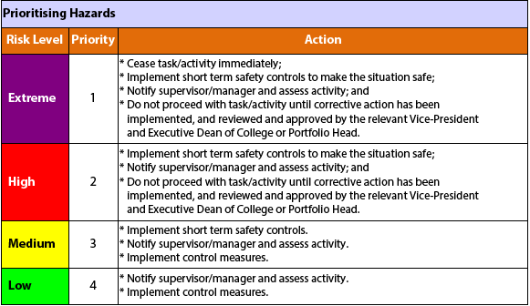
Control Hierarchy
Elimination | Remove hazard
Substitution | Use a less hazardous alternative
Isolation | Eg Restrict access, use in a closed container, fume cabinet
Engineering | Eg Trolleys to move loads, guards on machinery, Fume cupboard
Administration | Eg: Training, Safe Work Procedure, signage
PPE - Personal  Protective Equipment | Eg: Gloves, respirator, safety glasses

Risk Matrix
Consequence | Likelihood
 | Very likely | Likely | Possible | Unlikely | Highly unlikely
Catastrophic | Extreme | High | High | High | Medium
Major injury | High | High | High | Medium | Medium
Minor injury | High | Medium | Medium | Medium | Medium
First aid | Medium | Medium | Medium | Low | Low
Negligible | Medium | Medium | Low | Low | Low

