EMPLOYABILITY TOOLKIT – JOB ADVERT ANALYSIS & ORGANISATION RESEARCH
This task is one of an integrated but adaptable set developed by the Careers and Employability team for Flinders University educators to improve student preparedness for the 'world of work'. Use it as the basis for an assessment, non-graded assessment, or activity. Further information and the full framework is located here. Topic Coordinators are welcome to adapt these to purpose.
Task | Job Advert Analysis & Organisation Research
Task type | Written task or workshop activity
Length | Table mapping skills/knowledge/experience to evidence
Learning outcomes**
Employability skills | Self management; problem solving; planning and organising; critical thinking; reflection
Employability Toolkit Category | Develop and customise job applications and interview skills
ABCD* | Career building: students will improve on abilities to seek, obtain/create and maintain work (C7, P4)
*Topic Coordinator to map to learning outcomes; **Mapped to Australian Blueprint for Career Development

Task Objectives:
- Research employment opportunities of interest
- Analyse a job advertisement and/or position description
- Reflect on employability skills

Task Rationale:
A job application is your first opportunity to build a connection with a prospective employer, introducing yourself, your skills, knowledge and experience and why they should hire you. This task introduces you to the foundational research you will need to do to customise your written job applications including your resume, cover letter, selection criteria and interviews.
For advertised roles, valuable clues to help customise applications are provided in the job advertisement and accompanying position description. Position descriptions and advertisements don't all look exactly the same but generally they will provide insight into the qualifications, experience, skills, knowledge and personal attributes that the desired candidate will ideally possess to enable them to perform in the role.
Feedback from graduate employers has shown that graduates often submit applications or attend interviews demonstrating a failure to research the hiring organisation (AAGE Survey 2020). This research is essential to build a connection between your skills/experience, the role, and the prospective employer. Job advertisements and position descriptions will provide some insight but you should also investigate other avenues such as their website and any connections you may have.

Task Description:
Part 1
- Source a job advertisement (and/or position description) that is relevant to your chosen field
- Deconstruct the advertisement to identify the employability skills, knowledge and experience required for those jobs
- Record the information in Table 1 below
- In the third column provide real examples of instances where you have demonstrated / developed these identified aspects of employability (e.g. through work/volunteering/ community and academic experiences). These will be important to translate to your applications and interviews.
Table 1: Job Advert analysis and reflection
Identify the employability skill, knowledge and experience | Include the statement that mentioned this in the position description | Provide your own example of how you have demonstrated this skill or acquired this knowledge/experience
e.g. communication | You will also need demonstrated teamwork and communication skills coupled with a desire to grow and learn. | I have two years experience working part-time on the register at my local Coles supermarket. This position has enabled me to develop strong skills in customer service as well as the ability to communicate effectively with people of all ages and backgrounds.
e.g teamwork | You will also need demonstrated teamwork and communication skills coupled with a desire to grow and learn. | I led a team of four volunteers during a 2 week field trip to Fraser Island to monitor water quality. This experience grew my ability to organise and coordinate a team and I was commended by the Project Coordinator for my leadership and ability to effectively manage and build relationships to achieve project outcomes – and lasting friendships!
Part 2
- Research the organisation – see ‘Now what about them?’ for ideas
- Complete Table 2 demonstrating what you have learned
- What connections can you make (if any) that might be useful to impart during an application or interview process? How do you align with their values or mission? Do you have familiarity with one of their projects? Did you do a placement or site visit or attend an information event? These will be important to translate to your applications and interviews.
Table 2: Organisation research
Organisational characteristics (size, location(s), customers/partners/investors etc) | Vision and/or Mission Statement | Values | Current news | Key projects/specialities | Connections?

Information for Topic Coordinators
Topic Coordinators may like to supply an appropriate job advertisement and/or position description for this task. We have supplied a job advertisement below to demonstrate mark ups. This task may be best used as a precursor to tasks on resume and cover letter development.

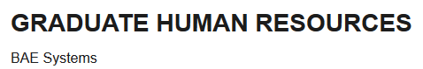
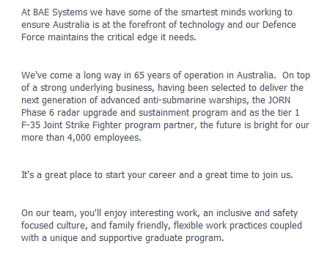
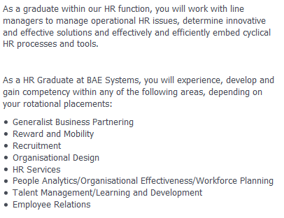
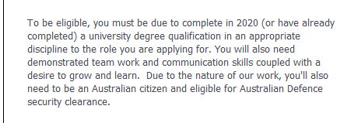
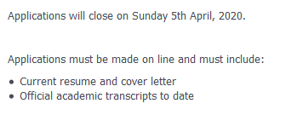
History, flagship projects, size
Culture
Role
Who they are, sector
Application instructions
Eligibility criteria, attributes
Role

